

**PROJECT**

**"Socio-economic conditions of the workers of informal Sector during Quota Reform movement,2024: A sociological study in Barisal city”**

**SUBMITTED TO**:

**MD. RASHID AL ASIF**

**Assistant Professor,**

**Department of CSE,**

**University of Barishal.**

**SUBMITTED BY:**

**MD. JAHIRUL ISLAM**

**EDGE ID : 01-52-20**

**Batch : 52**

Contents

**Abstract** 2

**1.Introduction** 2

1.1.Background of the Study 2

1.2.Rationale of the Study 3

1.3.Objectives of the Study 4

1.4.Research Question 4

1.5.Operational Definitions 4

1.6.Hypothesis 5

**2.Methodology** 5

2.1. Research Design 5

2.2. Research Method 5

2.3 Study Area 5

2.4. Study Population 5

2.5. Sampling Technique 5

2.6. Sample Size 6

2.7. Data collection Method 6

2.8. Data Collection Technique and tools 6

2.9. Unit of Analysis 6

2.10. Data Analysis 6

2.11. Validity and Reliability 6

2.12. Ethical Issues 7

2.13. Limitations 7

**3.Results** 7

3.1.Demographic Information of the Respondents 7

3.2. Educational background of the Respondents 8

3.3. Engagement in the informal sector of the Respondents 8

3.4. Respondents effected by quota Reform Movement 8

3.5. Impact on work 9

3.6. Impact on Income 9

3.7. Disruptions in the supply chain 10

3.8. Finding customers during the Quota Reform Movement 10

3.9. Change in occupation 11

3.10. Coping with the financial impact of the Quota Movement 11

3.11. Impact your mental health or well-being 12

3.12. Impact on family’s financial stability 12

3.13. Hope for Economic Recovery 13

3.14. Future Plan of Respondents in informal Sector 13

**4. Discussion** 14

**5. Conclusion** 14

**6.Reference** 16

**Socio-economic conditions of the workers of informal Sector during Quota Reform movement, 2024: A sociological study in Barisal city**

# Abstract

The Quota Reform Movement 2024 in Bangladesh, a significant social and political event, had far-reaching implications, particularly for the informal sector workers. This study aimed to investigate the socio-economic conditions of these workers in Barisal City during this period. Through a descriptive research design and quantitative methodology, the study collected data from a sample of 20 informal sector workers using a structured questionnaire. The findings revealed that the movement had a substantial negative impact on their livelihoods, leading to reduced income, job insecurity, and disrupted business operations. The study also highlighted the psychological toll, with many workers experiencing increased stress and anxiety. The research underscores the need for targeted support programs to help these vulnerable workers recover and adapt to the changing economic landscape. By understanding the challenges faced by informal sector workers, policymakers can develop effective strategies to mitigate the adverse effects of future social and political upheavals.

***Key Words:*** Quota Reform Movement 2024, Informal Sector Workers, Socio-economic Impact, Social and Political Upheaval, Barisal City.

# 1.Introduction

## 1.1.Background of the Study

The 2024 quota reform movement in Bangladesh emerged as a significant social and political event driven by dissatisfaction with the existing quota system for public sector recruitment and university admissions. This system, initially intended to ensure representation for marginalized groups, had been criticized over the years for becoming outdated and lacking meritocracy. The reform movement aimed to reduce the percentage of positions reserved under quotas, promote merit-based recruitment, and increase transparency in the selection process.

The movement began as student-led protests demanding quota reforms but soon escalated into a broader challenge against the government, fueled by widespread frustrations over corruption, economic issues, and allegations of election rigging. High inflation, corruption in public service recruitment (including reported exam question leaks), and abuses by the ruling party's student wing contributed to the unrest. As protests spread nationwide, the government's harsh response, including internet shutdowns and violent crackdowns, intensified the public outcry.

The impact of these events was felt particularly by informal sector workers, who often bear the brunt of economic instability. Inflation, reduced remittances, and political turmoil adversely affected their livelihoods. The movement highlighted the interconnectedness of socio-economic issues and governance, with the reform demands underscoring a need for inclusive policies that address both economic and social inequalities.

## 1.2.Rationale of the Study

The 2024 quota reform movement in Bangladesh, while aimed at addressing significant social and economic issues, may have had unintended consequences for the informal sector. This sector, which constitutes a large portion of the country's workforce, is particularly vulnerable to economic disruptions and social unrest. This study aims to investigate the socio-economic conditions of informal sector workers in Barishal City during this period, with the following objectives:

* **Understanding the Impact of the Quota Movement:** The quota movement may have led to closures, reduced business activity, and increased uncertainty for informal sector workers. Understanding the specific impact on this sector can provide valuable insights into the broader consequences of the movement.
* **Identifying Socioeconomic Vulnerabilities:** The informal sector is often characterized by precarious employment conditions, lack of social protection, and limited access to resources. This study can help identify the specific socioeconomic vulnerabilities of informal sector workers in Barisal city and assess how these vulnerabilities were exacerbated during the quota movement.
* **Assessing Coping Mechanisms:** Informal sector workers may have employed various coping mechanisms to survive during the disruptions caused by the quota movement. Examining these strategies can provide valuable lessons for policymakers and development practitioners in designing effective support programs.
* **Policy Implications:** The findings of this study can inform the development of targeted policies and interventions to support informal sector workers in Barisal city and other similar areas. These interventions could include social safety nets, job training programs, and access to financial services.
* **Contributing to Academic Knowledge:** This research can contribute to the existing body of literature on the informal sector, labor economics, and social movements. By examining the experiences of informal sector workers during a period of significant social and economic upheaval, this study can provide valuable insights into the resilience and adaptability of this population.

## 1.3.Objectives of the Study

1. To analyze the socio-economic conditions of informal workers in Barishal City during the 2024 quota reform movement.
2. To evaluate the movement's impact on these workers' livelihoods, employment, and well-being.
3. To identify and explore socio-economic challenges faced by informal workers in Barishal City during the movement.

## 1.4.Research Question

1. What were the socio-economic conditions of the informal workers during the quota reform movement period in Barishal city?
2. How did the quota reform movement impact the informal sector workers in Barishal City?
3. What were the socio-economic challenges faced by informal workers in Barishal City during the quota reform movement?

## 1.5.Operational Definitions

* **Socio-economic Condition**

Refers to the economic well-being, social circumstances, and overall quality of life for individuals involved in the informal sector in Barishal City. These conditions are shaped by income, job stability, access to essential services, and social support networks.

* **Workers in the Informal Sector**

Individuals engaged in economic activities that are often unregulated, lack formal contracts, job security, and typically fall outside of traditional labor laws. These workers may be involved in activities such as street vending, small-scale manufacturing, housework, and daily wage employment.

* **Quota Reform Movement 2024**

A student-led protest that took place from June to August 2024 in Bangladesh, opposing the reinstatement of a quota system for government jobs**.**

* **During the Quota Reform Movement 2024**

Refers to the period of the movement characterized by shutdowns, political unrest, violence, and crackdowns**.**

* **Barishal City**

The urban context in Bangladesh where the study was conducted, notable for its distinct economic, cultural, and social dynamics.

## 1.6.Hypothesis

* **Null Hypothesis (H₀):**

The Quota Reform movement of 2024 had no significant impact on the socio-economic conditions of informal sector workers in Barisal city.

* **Alternative Hypothesis (H₁):**

The Quota Reform movement of 2024 had a significant impact on the socio-economic conditions of informal sector workers in Barisal city*.*

# 2.Methodology

## 2.1. Research Design

This study is descriptive in nature, with an objective to systematically describe the socio-economic conditions of informal sector workers during the 2024 quota movement.

## 2.2. Research Method

A quantitative research methodology was employed.

## 2.3 Study Area

Barishal City, located in the southern region of Bangladesh, served as the study area. This riverine city, situated on the banks of the Kirtankhola River, lies approximately 180 kilometers south of Dhaka. Known for its cultural richness, Barishal has a diverse population, languages, and religious practices.

## 2.4. Study Population

The accessible population consists of informal sector workers present in various locations within Barishal City during data collection.

## 2.5. Sampling Technique

From non-probability sampling, the researcher has chosen purposive sampling technique

## 2.6. Sample Size

In this study, a sample of 20 informal sector workers were interviewed from different sites and locations of Barishal city.

## 2.7. Data collection Method

All the data have been collected from primary sources. For the study, the researcher has used survey method to collect data from primary sources. The most crucial reason for using survey is that the researcher can collect answers regarding definite and significant questions. These questions can be asked in multiple formats as per the accessible population and the intent of the survey.

## 2.8. Data Collection Technique and tools

Considering the facts and requirements of the survey a questionnaire was also carefully designed in this study; a structured questionnaire has been used to collect data from the selected sample. Respondents have been given 20 minutes on an average to answer these questions.

## 2.9. Unit of Analysis

Every single respondent of the research is considered as unit of analysis.

## 2.10. Data Analysis

In this research, data collected through sample survey has been presented and analyzed through software like MS Office, Microsoft Excel and with the help of output tables containing frequency, percentage etc. There is also a presentation with graphs or charts.

## 2.11. Validity and Reliability

As a measure of a research instrument or tool, validity is the degree to which it measures what it is supposed to measure (Wan, 2002). Reliability is a measurement instrument that is reliable is one that is stable or consistent across time (Kerlinger, 1986). Both aided the researcher in designing and judging his own work to evaluate research literature and interventions.

## 2.12. Ethical Issues

In every step of the study, the researcher followed research rules for collecting data from the different sources. Ethics in questions formatting and during data collection from the respondents have been maintained. The respondents' privacy has been maintained and harmful questions have been avoided. Misleading ascription of authorship has been avoided properly. There were no involuntary pressures on the respondents to take part on this study.

## 2.13. Limitations

1. Due to limited resources and time, this research was conducted with a small sample size, which may not be representative of the larger population.
2. It was challenging to gather information, as some respondents felt that participating was a waste of time.
3. Several respondents expressed skepticism about the survey's objectives and hesitated to continue the conversation.

# 3.Results

## 3.1.Demographic Information of the Respondents

Table-1 shows that the majority of respondents are in their working prime, with 25% under 25, 25% between 25-35, and 45% in the 36-45 age range. Only 5% are aged 46-55, and none are over 55, highlighting a middle-aged focus in the study. Regarding gender, 80% of respondents are male, while only 20% are female.

|  |  |  |  |
| --- | --- | --- | --- |
| Demographic | Category | Frequency | Percentage |
| Age | Under 25 | 5 | 25% |
| 25-35 | 5 | 25% |
| 36-45 | 9 | 45% |
| 46-55 | 1 | 5% |
| Over 55 | 0 | 0% |
| Gender | Male | 16 | 80% |
| Female | 4 | 20% |

Table-1: Demographic Information of the Respondents (Source: Field Survey, 2024)

## 3.2. Educational background of the Respondents

Figure-1 shows that 35% of workers in the informal sector have no formal education and another 35% having only primary education, 15% have completed secondary education, 10% have higher secondary education, and only 5% have a Bachelor of Social Science degree, indicating a trend towards lower education levels in the workforce.

Figure-1: Educational background of the Respondents (Source: Field Survey, 2024)

## 3.3. Engagement in the informal sector of the Respondents

The table-2 highlights the work experience distribution among informal sector workers, showing that 40% have less than 5 years of experience, 30% have 5-10 years, and 25% have 11-15 years. Only 5% have 16-20 years of experience, with no respondents reporting over 20 years. This indicates a predominantly younger workforce with few long-term workers.

|  |  |  |
| --- | --- | --- |
| Engaged in the informal sector | | |
| Time Period | **Frequency** | **Percentage** |
| Less than 5 Years | 8 | 40% |
| 5-10 Years | 6 | 30% |
| 11-15 Years | 5 | 25% |
| 16-20 Years | 1 | 5% |
| Over 20 Years | 0 | 0% |

Table-2: Time of Engagement in the informal sector of the Respondents (Source: Field Survey, 2024)

## 3.4. Respondents effected by quota Reform Movement

Figure-2 depicts the impact of the quota reform movement on informal sector workers, showing that 80% were directly affected and 20% experienced indirect effects. This contrast emphasizes the substantial direct impact of the reforms on most workers.

5%

60%

35%

Figure-2: Respondents effected by quota Reform Movement (Source: Field Survey, 2024)

## 3.5. Impact on work

The Figure-3 illustrated by impact of quota Reform movement on business or what among informal sector workers a significant portion 60% experienced a particular shutdown another 25% of business or work completely shut down manual 5% faces a significant reduction in operations though not a complete shutdown, notably there was no recorded minimal this disruption.



Figure-3: Impact on work (Source: Field Survey, 2024)

## 3.6. Impact on Income

In the Figure-4, We see in that most of the respondent claim that their income is substantially impacted, the percentage is 55%, besides, 45% respondent says their income is moderately impacted.

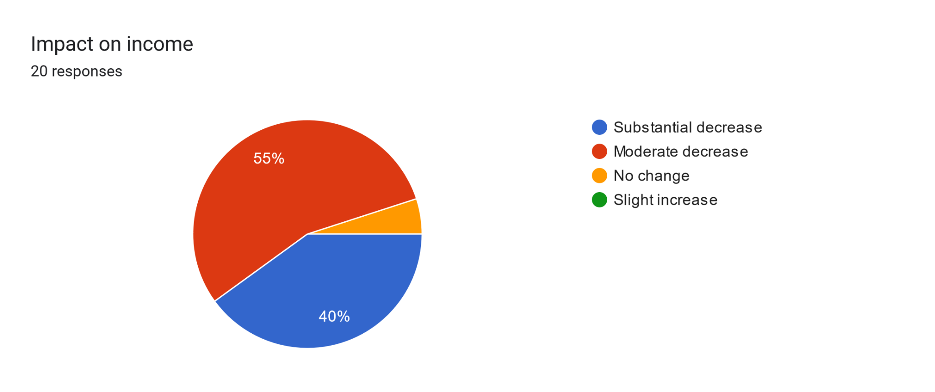

Figure-4: Impact on Income (Source:Field Survey, 2024)



## 3.7. Disruptions in the supply chain

In the Figure-5, When it comes to disruptions in the supply chain or access to raw materials, levels of disruption can be categized as Severely Disrupted (35%), Moderately Disrupted (55%), Minor Disruption (15%)

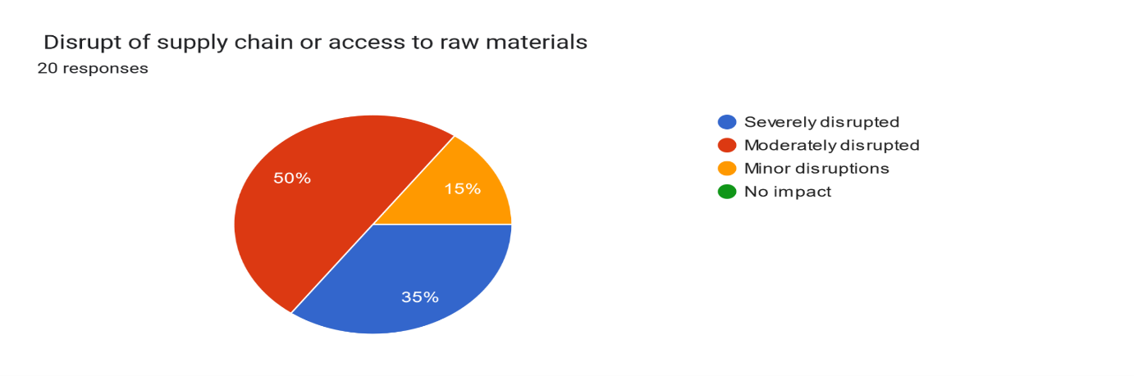



Figure-5: Disruptions in the supply chain (Source: Field Survey, 2024)

## 3.8. Finding customers during the Quota Reform Movement

The pie chart illustrates the distribution of customer acquisition outcomes during the quota reform movement. The largest portion, represented by 75%, consists of those facing challenges in finding customers., 10%, represents those who were able to find customers successfully despite the challenges posed by the reform. The final 15% segment highlights those who were completely unable to find any customers.

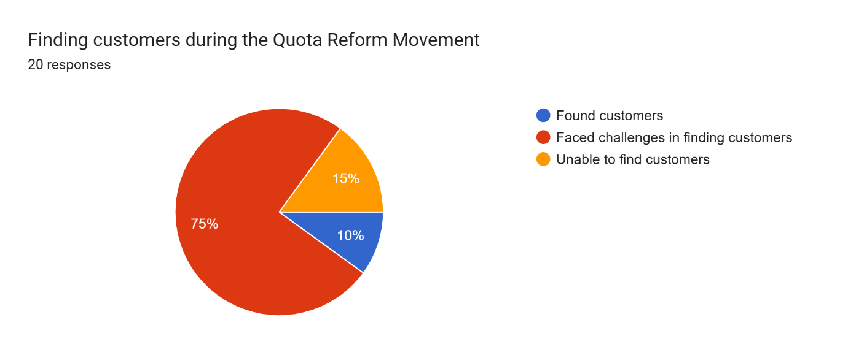

Figure-6: Finding customers during the Quota Reform Movement (Source: Field Survey, 2024)

## 3.9. Change in occupation

In the Figure-7, we saw Continued in the Same Occupation with Adjustment (50%): Changed Occupation (25%): This portion indicates that a quarter of the population switched to a different occupation Here, 20% of people did not make any changes, suggesting satisfaction or stability in their roles. Completely Changed Occupation (0%). There is no portion for complete changes, as 0% of the population underwent a complete transformation in their occupation without retaining aspects of the previous role.

20%

50%

25%

5%

Figure-7: Change in occupation (Source: Field Survey, 2024)

## 3.10. Coping with the financial impact of the Quota Movement

To depict coping with the financial impact of the quota movement using a bar chart, you can categorize different coping strategies or measures taken and their effectiveness. Here’s a suggested structure: The bar chart follows the coping with the financial impact of quota movement neither borrow money nor sell assets is 20%, borrow money 35%, both borrow money andsell assets 40%, and sell assets 5%.

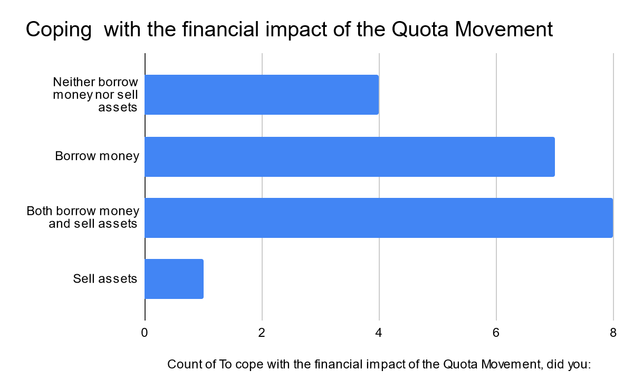

5%

40%

35%

20%

Figure-8: Coping with the financial impact of the Quota Movement (Source: Field Survey, 2024)

## 3.11. Impact your mental health or well-being

The pie chart represents the impact of various factors on mental health and well-being can be a useful way to visualize the balance of influences. Here’s a breakdown of common factors and how they might be represented in a pie chart: Significantly negatively impacted (40%), Moderately negatively impacted (45%), Minimal impact (10%), Moderately Positively impacted (0%), Significantly Positively impacted (5%).

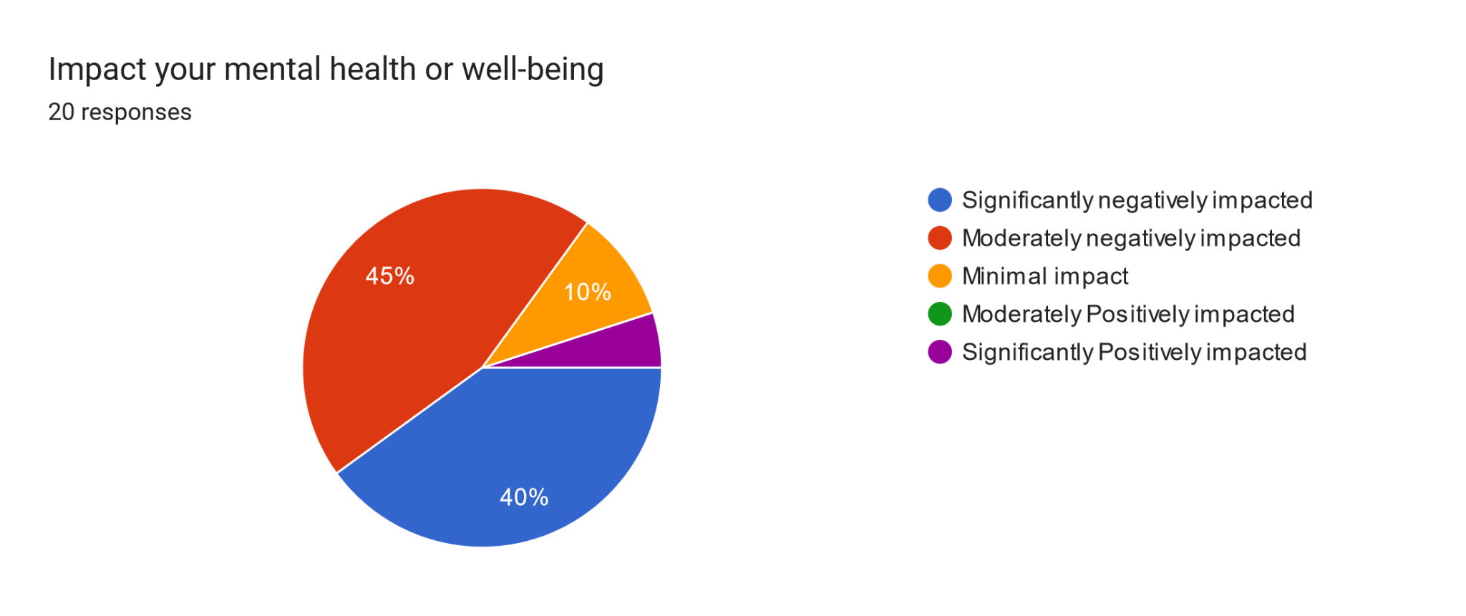

Figure-9: Impact your mental health or well-being (Source: Field Survey, 2024)

## 3.12. Impact on family’s financial stability

To represent the impact of various factors on a family's financial stability using a pie chart, you might break it down into the following components: Severely impacted (55%), Moderately impacted (35%), Minimally impacted (10%). This structure can help visualize how different factors contribute to a family's overall financial health.

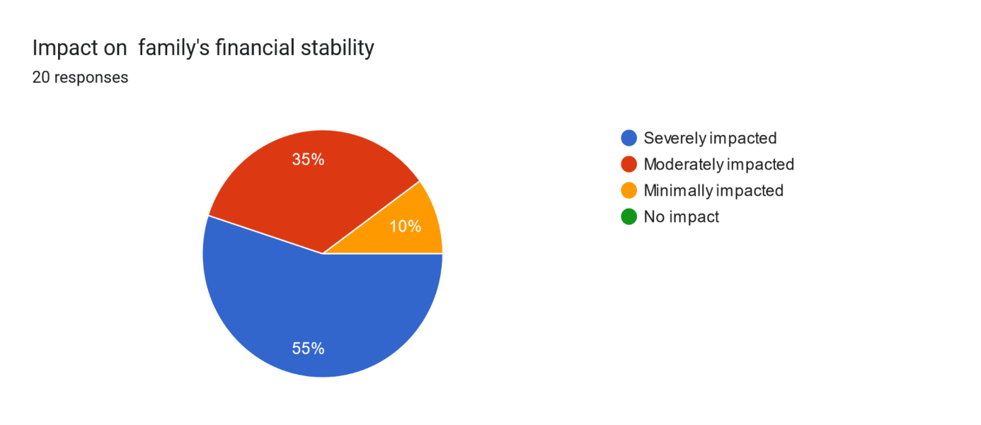

Figure-10: Impact on family’s financial stability (Source: Field Survey, 2024)

## 3.13. Hope for Economic Recovery

To illustrate the hope of economic recovery in the informal sector using a graph chart, you could create a line graph that tracks several key indicators over time. Here’s a conceptual outline: At first the graph chart saw the somewhat optimistic 60 percent and then it decreases 32 percent. Finally pessimistic more less and reach at 8 percent.

|  |  |  |
| --- | --- | --- |
| Hope for Economic Recovery | | |
| Opinion | **Frequency** | **Percentage** |
| Pessimistic | 1 | 5% |
| Somewhat Optimistic | 12 | 60% |
| Very Optimistic | 7 | 35% |

Table-3: Hope for Economic Recovery (Source: Field Survey, 2024)

## 3.14. Future Plan of Respondents in informal Sector

To illustrate future plans in terms of work or business using a graph chart, you could create a bar chart that categorizes various goals or initiatives. Here’s a suggested structure:This bar chart follow the first future plan start a new business in the informal sector is 25 percent, Secondly the bar chart describe the continue working in the informal sector is 60 percent, Thirdly the bar chart follow the future plane seek a different job within the informal sector is 10 percent, finally the future plane transition to a different sector or occupation is 5 percent

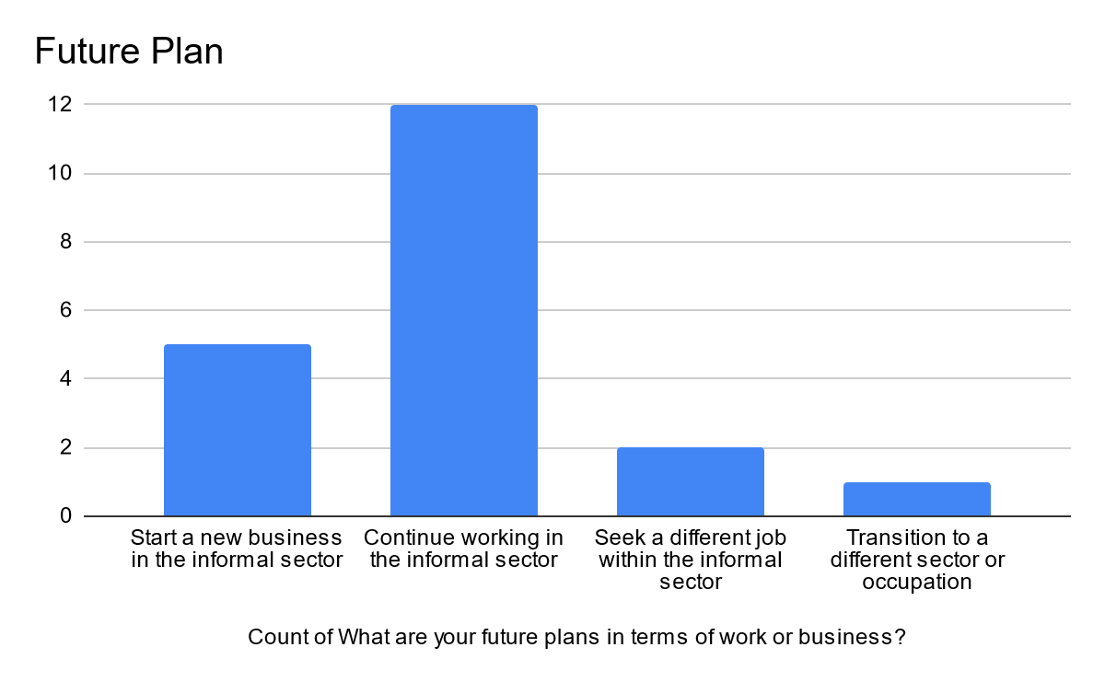

25%

60%

10%

5%

Figure-11: Future Plan of Respondents in informal Sector (Source: Field Survey, 2024

# 4. Discussion

* **Impact of Quota Reform Movement:** The movement had a significant impact on the informal sector, leading to business closures, income reduction, and supply chain disruptions.
* **Psychological Impact:** The economic hardships caused by the reform have negatively affected the mental health and well-being of respondents.
* **Coping Mechanisms:** Respondents have employed various strategies to cope with the financial impact, including borrowing money and selling assets.
* **Future Outlook:** While there is hope for economic recovery, many respondents are uncertain about their future plans and are considering alternative occupations.

# 5. Conclusion

The 2024 Quota Reform Movement in Bangladesh, while aimed at addressing systemic issues, had a significant impact on the socio-economic conditions of informal sector workers in Barisal City. This study aimed to delve into the experiences of these workers, highlighting the challenges they faced during this period of social and political upheaval.

Key findings from the study indicate that the movement led to a decline in business activity, reduced income, and increased job insecurity for informal sector workers. The disruptions in supply chains, reduced customer demand, and increased operational costs further exacerbated their economic vulnerabilities. Additionally, the movement's psychological impact cannot be overlooked, as many workers reported increased stress, anxiety, and feelings of isolation.

The study emphasizes the need for targeted support programs to help informal sector workers recover from the economic and social consequences of the movement. Such interventions could include access to microcredit, skills training, and social protection measures. Furthermore, policymakers should consider the specific needs of this vulnerable group when formulating future economic and social policies.

By understanding the experiences of informal sector workers during the Quota Reform Movement, this study contributes to a deeper understanding of the complex interplay between social movements, economic policies, and the livelihoods of marginalized populations. It underscores the importance of considering the impact of such movements on vulnerable groups and the need for inclusive and equitable development strategies.

# 6.Reference

1. Quota reform protests: Students block several points of Dhaka-Barisal Highway, *Dhaka Tribune*, 16 Jul 2024. Retrieved 26 Occtober,2024.
2. Quota protest: 15 injured in attack at Barishal University, *The Daily Star*, Jul 29, 2024. Retrieved 26 Occtober,2024.
3. De Soto, H., 1989, The Other Path: The Invisible Revolution in the Third World, L.B. Taurus, London.
4. The cost of crisis: Who will bear it? *The Daily Star*, Jul 29, 2024. Retrieved 27 Occtober,2024.

# 

‌